**How to Repair Your Phone's Charging Port Without Spending Money**

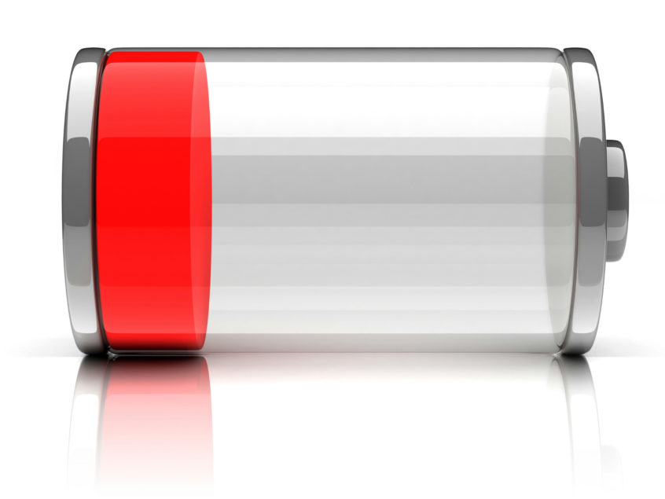

You never want to say these four words to yourself: "My iPhone won't charge." Imagine you're nearing the end of a hard day at work, preparing to rest for the evening, and your phone's battery is down to 10%. You believe this is a usual occurrence, and that your phone will receive its much-needed recharge so that it will be ready to send out hundreds of messages, tweets, Facebook posts, Instagram browsing, Snaps, and so on the following day. When you insert your iPhone into the charger, nothing happens.

You've completed the task. You've said those dreadful four words that send shivers up your spine. You begin to sweat, you're exhausted yet anxious, and you're at a loss for what to do. This scenario has the potential to be disastrous. You've tried disconnecting and replugging your phone into the charger, but it's still not working. Then you try to shove the charger into your phone, assuming that physical force would fix the problem. However, this does not work in the end. You're on the edge of crying in your bed, unable to charge your phone, which is ready to die.

While we at M6Repairs had no intention of writing a horror novel, we feel compelled to share this information with everyone so that if you find yourself in this scary scenario, you won't panic. There are several options for repairing your charging port, including some that you can perform yourself!

**You Can Do It Yourself**

One of four things is most likely to blame for your iPhone's inability to charge:

* The software on your iPhone is preventing it from charging.
* The charger/lightning cable has been damaged.
* The Wall Adapter has been harmed.
* The charging port on the bottom of your iPhone is broken or something is obstructing the connection.

**The software on your iPhone is preventing it from charging**

Let's start with the simplest solution: the software on your phone. It's the software that instructs your phone to charge when you plug it in. To try this procedure, you'll need to do a hard reset or force reset on your phone. Hold both the on/off and the home buttons for up to 30 seconds to perform a hard reset. Your phone will eventually restart, with the screen becoming black first, then the Apple logo appearing on the screen. Stop holding both buttons when the Apple logo shows and let the phone restart. After the phone has completely rebooted, try connecting it into your charger. Hopefully, this simple method was successful in resolving your issue. If that isn't the case, you'll want to move on to the next option.

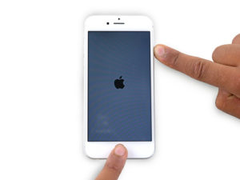

**The charger/lightning cable has been damaged**

Examine your Lightning Cable to check if there is any noticeable damage to it. Inspect the cord as well as the connection. If you see any damage, it may be time to purchase a new Lightning Cable. If there is no obvious damage, try charging your iPhone with your computer by connecting it to your Lightning Cable and then plugging the cable into your computer's USB port. If this procedure fails, you may have found the source of the problem. Finally, please keep in mind that non-Apple (off-brand) Lightning Cables are more likely to wear out and break than Apple Lightning Cables.

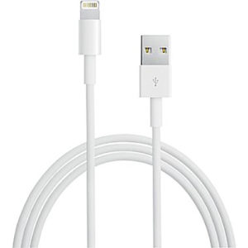

**The Wall Adapter has been harmed**

If the first two procedures failed, it's time to look at your Wall Adapter. Trying inserting your Wall Adapter into a different outlet is the simplest approach to ensure it is operating properly. This may seem silly, but there are instances when a fuse in your house or apartment blows, leaving one outlet or room without electricity. Use a different Lightning Cable if your outlets are working correctly. If both cords yield the same result, you'll know your Wall Adapter is broken.

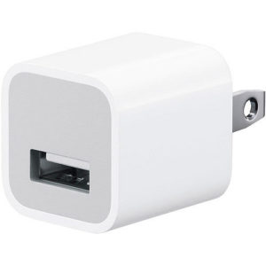

**Your iPhone's bottom charging port is damaged or has anything blocking the connection**

Finally, if everything else fails, it's time to channel your inner MacGyver and become technical. Most of the time, the Charging Port is to blame for your iPhone's inability to charge. To begin, obtain a flashlight and look into the port directly to check if there is any visible debris (lint, muck, etc...). If there is, it should be simple to delete (more on that later). If there isn't any apparent debris, it's possible that it's lurking somewhere you can't see it.

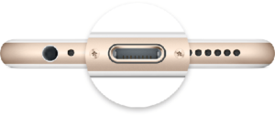

So, what's the best way to get rid of the annoyance from your iPhone's charging port? BE VERY CAUTIOUS!! You can carefully brush away any apparent dirt with a new, unused toothbrush. You may also use a cue tip, which is non-invasive and soft. We highly advise against using toothpicks or paperclips since they may cause harm to the charging port. Because paperclips carry electricity and are extremely sharp, they are particularly dangerous. If your strategy is successful, visible debris will begin to depart the Charging Port. This is a strong hint that the Charging Port is to blame. Charge your phone once more when you've dislodged enough junk.

**When You've Tried Everything and Still Can't Get It Fixed**

Hopefully, the do-it-yourself solutions have solved your issue. However, there are situations when you can attempt everything and still not get the results you want. It's now time to take your phone to a phone repair shop.

Customers with this issue visit M6 Repairs on a regular basis. They barge into the store and begin begging our employees to fix their phone. Usually, their phone is dead at this point. There's nothing more annoying than a dead phone that won't charge!

So, how can we figure out what's wrong and how to repair it? First, we put everything you've attempted at home to the test. Many clients, believe it or not, may have ignored a minor issue. It's not unusual for one of our employees to test a fresh Lightning Cable and have the phone charge. "But," a client once replied, "I tried it at home." "I tried everything you said, and it didn't work!"

Don't be too hard on yourself. This happens all the time. A bad Lightning Cable or a faulty Wall Adapter was the source of your problem. It occurs to the most well-intentioned among us. After we've ruled out all other possibilities, it's possible that your Charging Port is damaged.

Our fully qualified specialists at [M6 Repairs](https://m6repairs.co.uk/) can repair your cell phone and replace your Charging Port in no time, getting you back up and running.

**What if the problem isn't with the charging port?**

We'll check at your battery if your Charging Port isn't damaged and we've determined that your phone is in good functioning order. This is frequently the cause of your iPhone's inability to charge. This is, however, a simple and quick repair. While you wait, Forever Wireless will replace your battery and fix your phone!

So, if you ever try to plug your phone in and say these four horrible words, "My iPhone won't charge," you now have the expertise to repair the problem. First, see if you can repair it yourself. BUT WARNING: BE CAREFUL! You don't want to further harm your phone or cause a new problem.

You might wish to bring your iPhone to M6 Repairs for help with this all-too-common issue.

Finally, if you're still having difficulties after all of this troubleshooting, call [M6 Repairs](https://m6repairs.co.uk/) for iPhone repairs.